1 Hour 10 Minutes
Everything that didn’t go wrong went right!
Aparentally to use variable in a function you have to define it as “global Var”, Var being the variable in this case. I also got some of my variable wrong during the for loop causing a syntax error.
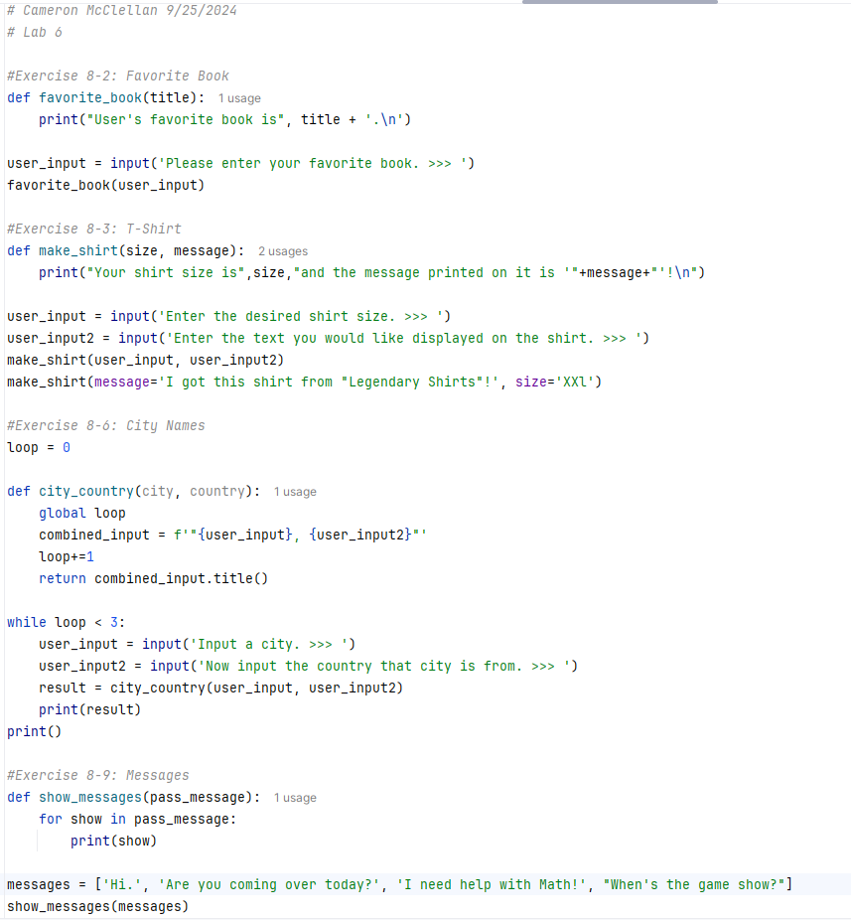
Defenintly learned things I didn’t know like passing arguments into functions. :)

